• Points from σ₂ = σ₃ → triaxial compression
• Points from σ₂ = σ₁ → triaxial extension
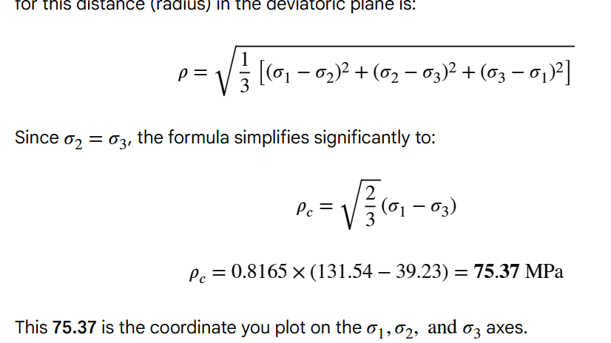
For extension put sigma 1 and 3 values what u got
RMR Value | Rock Quality | Description | Engineering Behaviour
0 – 20 | Very Poor rock | Highly fractured, crushed, or soil-like rock mass | Extremely unstable; immediate heavy support required
21 – 40 | Poor rock | Many joints, weak rock mass | Unstable without support; systematic support required
41 – 60 | Fair rock | Moderately jointed, some weathering | Fair stability; support needed in most cases
61 – 80 | Good rock | Slightly jointed, mostly intact | Generally stable; only local support required
81 – 100 | Very Good rock | Massive, strong, few discontinuities | Very stable; little or no support required

Overcoring Procedure using USBM Borehole Deformation Gauge
The overcoring (often typoed as "overcoming") method is a stress-relief technique used to determine the in-situ stress state of a rock mass. The USBM (U.S. Bureau of Mines) gauge specifically measures the diametrical deformation of a borehole as it is being stress-relieved.
Procedure
- Main Hole Drilling: A large-diameter hole (typically \(150\text{ mm}\) or \(6\text{ inches}\)) is drilled to the depth where the stress measurement is required. The bottom is then ground flat.
- Pilot Hole Drilling: A smaller concentric pilot hole (approx. \(38\text{ mm}\)) is drilled about \(300\text{ mm}\) to \(500\text{ mm}\) further into the rock mass.
- Gauge Insertion: The USBM gauge, which contains three pairs of cantilever transducers spaced \(60^{\circ }\) apart, is inserted into the pilot hole. Initial diameter readings are taken.
- Overcoring: A large-diameter thin-walled diamond bit overcores the pilot hole. This process physically detaches the cylinder of rock containing the pilot hole from the surrounding rock mass, effectively "relieving" the in-situ stresses.
- Data Recording: As the bit advances, the gauge records the expansion (deformation) of the pilot hole diameters. This expansion occurs because the rock "relaxes" once the external stresses are removed.
- Property Testing: The recovered rock core is then tested in a laboratory (often using a biaxial chamber) to determine the Young’s Modulus (\(E\)) and Poisson’s ratio (\(\nu \)). These values are used to convert the measured deformations into stress components.
Sketch Representation
text
Step 1: Main Hole Step 2 & 3: Pilot Hole Step 4: Overcoring
& Gauge Insertion (Stress Relief)
_________ _________ _________

| | | | | | | |
| | | | | | | |
| | | | | | | |
|_________| |____ ____| |__| |__|
| | | |
|G| <--- Gauge | G | <--- Core
|_| |___| detached
llllllllllllllllllllllllllllllllllllllllllllllllllllllllllllllllllllllllllllllllllllllllllllllllllllllllllllllllllllllllllllllllllllllllllll

